Name......................................Date............................A.....................................Mark.............................
- Solve simultaneous equations:
- 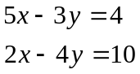

b) 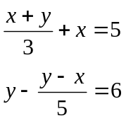

c) 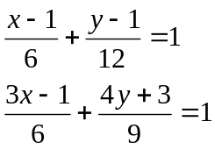

- Find out, if 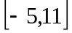 is a solution of this system of equations: 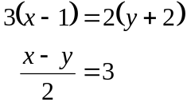.

- Find x, if y equals to 2: 

